**1 – Process Scores in a Text File**





**- - - - - - - - -**





**2 – Solving triangles from file input**

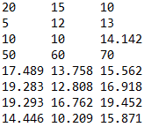

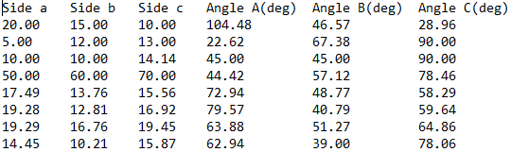

**3 – Big Data**

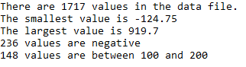

**4 – Reading varying integers from a file**

File.txt:

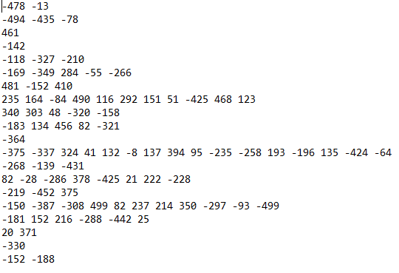

Output:

